# Hvad skal der laves?

Trin 1. Setup

* Komponenter √
* Display √
* Kode √(noget af det)

Trin 2. Opsamling

Trin 3. Data upload

Trin 4. Data håndtering

# Arbejdsplan

So vi har 2 voltage supplies.

0 -> 30 = 5V

30 -> 60 = 3,3V

Selv om det er fristende at give wireless 5V, er dette strengt verbotten.

## Mid term rapport

Resume:

Our general plan for this were to have a center for all our different sensor. With a keypad, we would then want to choose which of the sensors we would look upon. The data would then be manipulated, and we would then, if all went well, make communication between the arduino and the internet.

Chronological order

* Connecting the display:
  + Replacing the 10kΩ potentiometer, using a parallel circuit with 2 resistors.

We did this, so that we didn’t have to use the potentiometer, and so that the display would just show our chosen amounts of light.

This could also come in handy if we were to make connections without a breadboard.

* Connecting the keypad:
  + Easy to connect as we already knew how to implement it correct.
* Putting software from every sensor into one document.
* Making the navigational system.
  + As we had to make a delay for each cycle, the reading of which button was pressed would then also be delayed.
  + Working around this issue were tricky. We didn’t want to work with an asynchronous setup, as our experience with that in C isn’t great, and this could have been a large challenge.
  + We tried to make a tickrate system, but we had overlooked, that this would have required an asynchronous system as well.
  + We chose to just go with the delay, knowing that this wouldn’t be the best of all systems.
* As we had set all of this, we then had two goals remaining:
  + Making a wireless connection:
  + Making a case for our setup, made from 3D printing.
* The wireless connection has been the most difficult challenge of the two. The one esp8266 that we received from embedded stock, didn’t work as it should have, so we ended up getting an esp32 as a replacement.
* Making the wireless connection with the esp32 and getting the case print ready is where we have come too.

## Problemer

### Den 24 April

*At der fås fejlkoder fra esp32, er det problem der i dag skal løses. √*

*Data transfer skulle gerne ske mellem Arduino og Esp, så arduinoen kan kalde eller skrive data til en database igennem esp’en.*

* *Fremskridt, Esp’en connector.*

*Connection til iphone internet deling.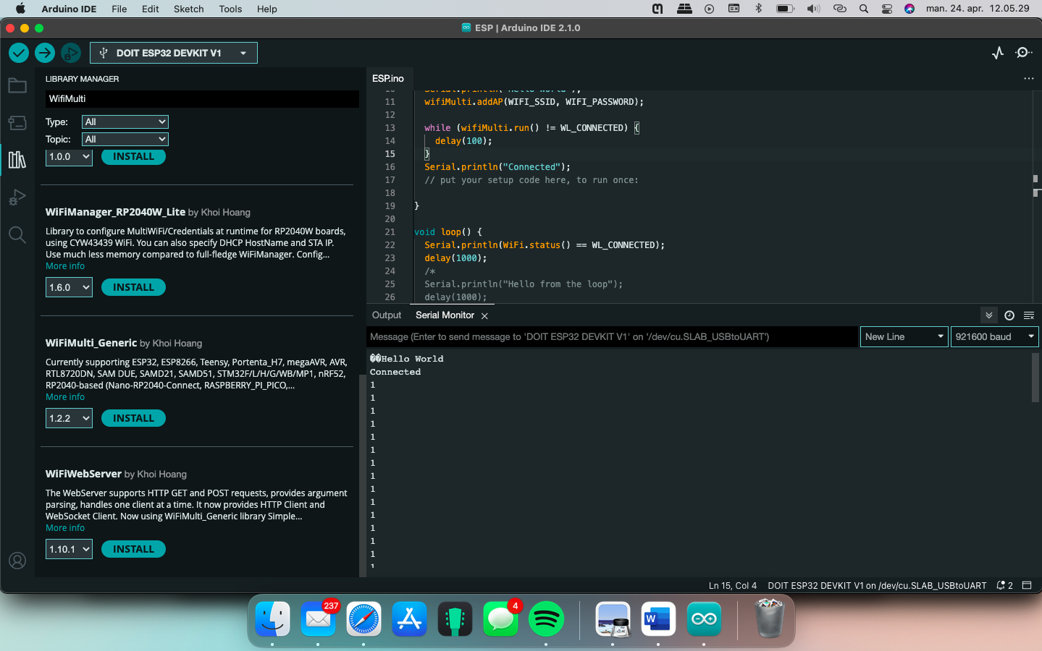*

Send data til og fra firebase

* Med forbindelse til firebase og wifi så mangles der at håndtere dataen.
* Dataen skal kunne sendes til firebase.
* Esp’en skal også programmeres, så den uploader data så snart den modtager data fra arduinoen.

Hvad jeg har fundet ud af!

* Firebase har som standard sat read og write tilladelserne til at være false, hvilket har gjort, at jeg har fået error koden ”Permission denied”

Næste opgave er at få data læst ordentligt på esp’en af det data der bliver sendt af arduinoen.

* Det er som om, at dataen ikke bliver overført ordentlig til esp’en.
* Debugging af hvad der kommer fra digitalRead af alle datapins kunne være næste skridt.

*At funktionaliteten fra alle sensorer ikke er som de skulle være er også et problem. √*

* *DHT’en fortæller ikke om planten skal vandes. √*
* *Lyssensor fortæller ikke, om lyset er tændt eller slukket. √*
* *Røgsensor sender ikke signal til buzzeren om, at den skal hyle. √*
* *Bevægelsessensorer fortæller faktisk, om der er bevægelse, og det er det eneste den skal, så den er i vinkel.*

*Med koden til alt funktionaliteten i vinkel, så er mit spørgsmål, om det hele kan køre sammen?*

*Tanken er, at jeg skal opdaterer display, men jeg vil også gerne tjekke sensorerne.*

*Umiddelbar tanke er, at det ikke behøves at køre asynchrounous men, at det bare kører kronologisk. Så i loopet, tjek sensorer, hvis display.*

## Feedback

Fra vores midterm rapport har vi fået feedback fra Hooman.

I det feedback vi fik forklarede han, at det ville være godt, hvis vi kunne demonstrere noget på næste mandag.

Så der burde vi have styr på det grundlæggende. Brug af alle sensorer og så videre.

Hvad jeg vil tage med herfra er, at det nok er bedst at få grundbasen til at fungere.